**CS – 634 102 Data Mining**

**Midway Report for Project**

**Restaurant Recommender**

**Group Members: -**

Yashwanth Kolipaka (yrk4)

Budesh Rohith Raju Poori (bp68)

Soumilee Ghosh (sg342)

Introduction of problem –

We have taken up the problem of recommending a restaurant just like we see in various applications like Uber Eats or DoorDash but we have added an extra feature to it, which is finding out the emotion of the user and based on it making our recommendation.

What we have done so far –

For Emotion Detection – In emotion detection we have used Keras image processing algorithm and Keras library that includes Keras facial model and Keras Layers. To train the module, Keras would take 32 images of the candidate and zoom the image and also grayscale to remove noise. It would then convert the images into kernels. Each set had multiples of 32 and the highest set had 256 images considered as neurons. Data is stored in a .xml file which in turn gets used OpenCV to detect emotions.

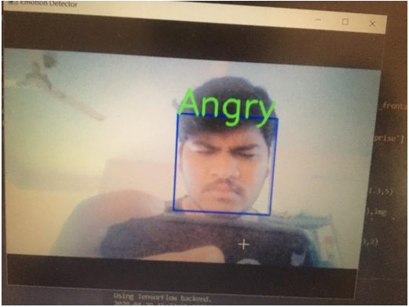

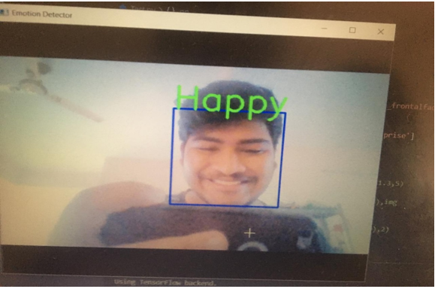

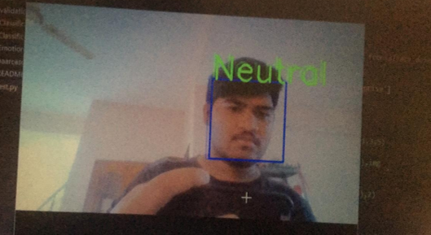

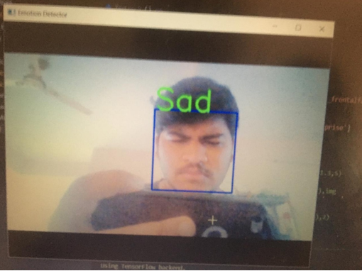

These are the four emotions we have decided to detect so far.

For our data set we are using a data set provided by Zomato (Indian Food delivery app). For building our website we are using ReactJS in the frontend and our Data is stored in clever cloud and our backend is created by using Python in the IDE Microsoft Visual Studio.

For cleaning our data, we have selected the data from the Zomato.csv file and removed all the entries which have the longitude and latitude as ‘0’. We have chosen several attributes for our data mining process some of them are – cuisine, average cost for 2, has table booking, is taking orders now, currency, country, address etc. Then we have decided to use K means clustering to find out where the high rated restaurants are located and find out the median rating of the restaurants in each cluster. Then we have taken another dataset food_choices.csv in it there is almost 124 entries with 61 attributes but we have decided to take the attibutes comfort_food and comfort_food_reasons, and depending on the emotion we are mapping the kind of food they would want to eat and, in this way, we want to suggest the restaurants to the user on basis of their emotion.